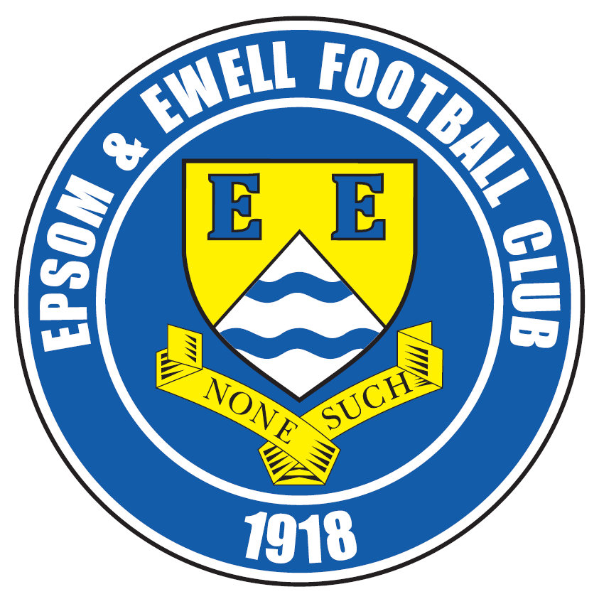 | Epsom & Ewell F.C.  17  v  Spelthorne Sports  Saturday, 7th January 2017 – 3.00 p.m.
Good afternoon and Happy New Year! We welcome the players, supporters and officials of Spelthorne Sports, today’s officials and of course, our own regular faces.

Today’s meeting is our final one against a new club this season. In other words, we have played all our other 21 league opponents so Spelthorne now complete the set! Hopefully we can continue our good form against them, as we have won all four of our previous League contests to this point. This came after our first meeting in 2014 which was a defeat here on penalties, following a 0-0 draw after extra time in the Southern Combination Cup Semi-Final.

Our last match here was at home to Raynes Park Vale which saw the continuance of a very worrying trend as we drew 1-1. We have been well in charge of most of our recent matches, yet as soon as we have gone ahead, have then struggled to hold on to the lead. It is one of the reasons we have drawn three of our last four at High Road, but we are still unbeaten here in the league since August, so it’s not all bad!

On Monday we made the short journey to Gander Green Lane for our match against Sutton Common Rovers on the Astroturf, and again we had to settle for a 1-1 draw. This time we trailed at half time and had to rally with ten men, after Dan Dean received a second yellow card, but Jordan Gallagher tucked away the late equaliser to secure the point from a match where neither side probably deserved to win.

Our next match is on Tuesday when we host Guildford City in the last 16 of the Surrey Senior Cup. Ironically we also meet them the following Tuesday in a League match, separated only by a trip to Hanworth Villa next Saturday. Finally, our League Cup Quarter Final at Walton & Hersham has now been set for Tuesday 31st January.

We are also still looking for match and player sponsors, so if you would like to help us, please speak to any Committee Member and we can arrange this for you. The cost of a sponsorship is £55 but this includes three free entries, match programmes and hospitality, so is a really good deal. Many other clubs charge far more. Player sponsorship is £40 and for this you will get your name in the programme for the season, which can be useful particularly if you are a local business as we can place contact details there too.

Enjoy the game!

Rich

You can follow us on Facebook: www.facebook.com/epsomandewellfc
Twitter: @EEFCOfficial Instagram at: www.instagram.com/epsomandewellfc
and on Youtube at: www.youtube.com/channel/UCtLrpS0x5OaYUACRT34_zng

Cover photos by Gemma Jarman

- Rob Hendry heads our opening goal in the 2-1 home win over Chertsey Town

- Jordan Gallagher flicks the ball in for our second goal in that match


Cherry Red Records Combined Counties League
Premier Division Table 2016/17
incl Monday 2nd January | P | W | D | L | F | A | Pts | GD | H | A
Hartley Wintney | 27 | 22 | 3 | 2 | 87 | 26 | 69 | +61 | 18/3 | 1-3
Hanworth Villa | 28 | 16 | 5 | 7 | 50 | 31 | 53 | +19 | 2-2 | 14/1
Westfield | 25 | 15 | 6 | 4 | 56 | 29 | 51 | +27 | 18/2 | 1-2
Walton & Hersham | 24 | 13 | 9 | 2 | 42 | 22 | 48 | +20 | 4/3 | 1-1
Horley Town | 24 | 13 | 5 | 6 | 56 | 36 | 44 | +20 | 3-0 | 17/4
Camberley Town | 25 | 15 | 4 | 9 | 52 | 30 | 40 | +16 | 0-0 | 1/4
Epsom & Ewell | 24 | 11 | 7 | 6 | 55 | 35 | 40 | +20 | X | X
Knaphill | 25 | 12 | 3 | 10 | 51 | 49 | 39 | +2 | 4-0 | 8/4
Bedfont Sports | 23 | 11 | 5 | 7 | 42 | 41 | 38 | +1 | 5-1 | 7/2
Guildford City | 28 | 11 | 5 | 12 | 58 | 59 | 38 | -1 | 17/1 | 2-0
Windsor | 28 | 10 | 6 | 12 | 49 | 50 | 36 | -1 | 2-0 | 1-2
Abbey Rangers | 26 | 10 | 5 | 11 | 42 | 49 | 35 | -7 | 7-1 | 20/2
North Greenford United | 24 | 10 | 4 | 10 | 51 | 46 | 34 | +5 | 22/4 | 1-2
Colliers Wood United | 24 | 9 | 7 | 8 | 42 | 40 | 34 | +2 | 14/4 | 0-5
Spelthorne Sports | 25 | 9 | 5 | 11 | 42 | 45 | 32 | -3 | 7/1 | 25/2
AFC Hayes | 25 | 7 | 6 | 12 | 39 | 49 | 27 | -10 | 2-2 | 28/1
CB Hounslow United | 24 | 8 | 2 | 14 | 37 | 53 | 26 | -16 | 1-5 | 24/1
Sutton Common Rovers | 22 | 7 | 4 | 11 | 30 | 39 | 25 | -9 | 2-1 | 1-1
Farnham Town | 24 | 7 | 3 | 14 | 36 | 54 | 24 | -18 | 25/3 | 2-1
Chertsey Town | 26 | 6 | 6 | 14 | 34 | 63 | 24 | -29 | 2-1 | 11/2
Raynes Park Vale | 26 | 4 | 6 | 16 | 31 | 57 | 18 | -26 | 1-1 | 1-1
Badshot Lea | 25 | 5 | 3 | 17 | 32 | 67 | 18 | -35 | 4/2 | 4-1
Bedfont & Feltham | 26 | 4 | 5 | 17 | 31 | 75 | 17 | -44 | 21/1 | 9-2

Lucky Day? - 7th January
Played 14 - Won 6 Drawn 2 Lost 6 - For 31 Against 25 - PPG 1.43 - Average
Our Club record against today’s opponent
Played 5 - Won 4 Drawn 1 Lost 0 - For 15 Against 6 - PPG 2.60 - Fantastic
Our Largest wins and losses against today’s opponent
12th September 2015 - Won 6-2 - Combined Counties League (A)
24th April 2014 - Lost on penalties after 0-0 draw - Southern Combination Cup SF (H)
Their Last Visit
1st March 2016 - Won 2-1 - Combined Counties League

First Eleven Appearances 2016/17 - (max 32)
Name | Debut | 2016/17 |  |  |  | Career Totals
Name | Debut | App | Sub | Total | Goals | App | Sub | Total | Goals
CLARK-GLEAVE Charlie | 23/08/2016 | 2 | 2 | 4 | 0 | 2 | 2 | 4 | 0
COOPER-SMITH Daryl | 03/01/2015 | 24 | 1 | 25 | 25 | 54 | 9 | 63 | 45
DEAN Dan | 02/08/2014 | 23 | 2 | 25 | 0 | 91 | 6 | 97 | 2
DEWAR Ali | 29/10/2011 | 0 | 1 | 1 | 0 | 55 | 36 | 91 | 10
EACOTT Michael | 02/08/2014 | 25 | 0 | 25 | 0 | 110 | 1 | 111 | 0
FARRELL Matt | 02/08/2014 | 30 | 0 | 30 | 13 | 116 | 4 | 120 | 31
FERDINANDO Matt | 20/09/2014 | 15 | 6 | 21 | 2 | 68 | 12 | 80 | 16
GALLAGHER Jordan | 07/08/2016 | 18 | 12 | 30 | 9 | 18 | 12 | 30 | 9
GRIFFIN Reisse | 08/08/2015 | 23 | 5 | 28 | 2 | 51 | 11 | 62 | 4
HASTINGS Craig | 08/08/2015 | 21 | 5 | 26 | 1 | 58 | 9 | 67 | 1
HEAGNEY Adam | 16/08/2016 | 20 | 4 | 24 | 0 | 20 | 4 | 24 | 0
HENDRY Rob | 08/08/2015 | 22 | 7 | 29 | 5 | 52 | 18 | 70 | 17
MCKAY Alex | 20/12/2008 | 16 | 3 | 19 | 3 | 124 | 33 | 157 | 11
NEALE Tom* | 13/10/2015 | 6 | 5 | 11 | 7 | 22 | 24 | 46 | 17
NORTH Rhys* | 16/08/2015 | 2 | 2 | 4 | 0 | 19 | 9 | 28 | 1
NWACHUKWU Jason | 01/10/2016 | 5 | 8 | 13 | 0 | 5 | 8 | 13 | 0
PANAYIOTOU Savvas | 03/01/2015 | 25 | 3 | 28 | 4 | 57 | 11 | 68 | 11
PRICE Matt* | 23/08/2016 | 2 | 0 | 2 | 1 | 2 | 0 | 2 | 1
ROBINSON Sam* | 22/10/2011 | 7 | 1 | 8 | 1 | 61 | 6 | 67 | 14
ROSE Daniel | 25/10/2016 | 2 | 5 | 7 | 0 | 2 | 5 | 7 | 0
SALEH Mennar* | 24/09/2016 | 0 | 2 | 2 | 0 | 0 | 2 | 2 | 0
SMITH Matt | 08/08/2009 | 0 | 2 | 2 | 1 | 91 | 45 | 136 | 11
TANTON Matt | 02/08/2014 | 27 | 1 | 28 | 1 | 84 | 5 | 89 | 3
TAYLOR James | 26/08/2013 | 26 | 3 | 29 | 2 | 112 | 15 | 127 | 8
THOMPSON Elliott | 09/02/2016 | 3 | 0 | 3 | 1 | 7 | 9 | 16 | 1
TURPIE Alistair | 31/03/2016 | 7 | 1 | 8 | 0 | 9 | 1 | 10 | 0
WATRET Jack* | 02/08/2016 | 1 | 0 | 1 | 0 | 1 | 0 | 1 | 0
* player has left the club

Latest Results and Fixtures
Combined Counties League Cup 3rd Round – Monday 19th December
Sutton Common Rovers | 1-3 | Walton & Hersham
Combined Counties League – Tuesday 27th December
Abbey Rangers | 4-3 | Spelthorne Sports
Bedfont & Feltham | 3-1 | CB Hounslow United
Bedfont Sports | 1-0 | North Greenford United
Camberley Town | 5-1 | Farnham Town
Chertsey Town | 3-4 | Horley Town
Epsom & Ewell | 1-1 | Raynes Park Vale
Hanworth Villa | 1-1 | AFC Hayes
Hartley Wintney | 2-2 | Badshot Lea
Walton & Hersham | 2-2 | Westfield
Windsor | 1-1 | Knaphill
Combined Counties League – Monday 2nd January
AFC Hayes | 1-0 | Windsor
Badshot Lea | 0-2 | Camberley Town
Bedfont & Feltham | 0-4 | Hanworth Villa
Guildford City | 2-3 | Abbey Rangers
Hartley Wintney | 2-0 | Farnham Town
Horley Town | 4-0 | Raynes Park Vale
North Greenford United | 3-0 | CB Hounslow United
Spelthorne Sports | 2-1 | Bedfont Sports
Sutton Common Rovers | 1-1 | Epsom & Ewell
Walton & Hersham | 4-2 | Knaphill
Westfield | 1-3 | Chertsey Town
Combined Counties League – Saturday 7th January
Abbey Rangers | V | Bedfont & Feltham
Bedfont Sports | V | Hartley Wintney
Camberley Town | V | Walton & Hersham
CB Hounslow United | V | Horley Town
Colliers Wood United | V | AFC Hayes
Epsom & Ewell | V | Spelthorne Sports
Farnham Town | V | North Greenford United
Hanworth Villa | V | Westfield
Latest Results and Fixtures
Combined Counties League – Saturday 7th January
Knaphill | V | Badshot Lea
Raynes Park Vale | V | Guildford City
Surrey Senior Cup Third Round – Tuesday 10th January
Badshot Lea | V | Raynes Park Vale
Chertsey Town | V | Kingstonian
Epsom & Ewell | V | Guildford City
Merstham | V | Walton & Hersham
Combined Counties League – Tuesday 10th January
AFC Hayes | V | Bedfont Sports
Combined Counties League – Saturday 14th January
Abbey Rangers | V | Camberley Town
AFC Hayes | V | Westfield
Bedfont Sports | V | Chertsey Town
Farnham Town | V | Raynes Park Vale
Guildford City | V | Knaphill
Hanworth Villa | V | Epsom & Ewell
Horley Town | V | Sutton Common Rovers
North Greenford United | V | Colliers Wood United
Spelthorne Sports | V | Hartley Wintney
Walton & Hersham | V | CB Hounslow United
Windsor | V | Badshot Lea
Combined Counties League – Monday 16th January
Sutton Common Rovers | V | Windsor
Combined Counties League Cup QF – Tuesday 17th January
Westfield | V | Camberley Town
Combined Counties League – Tuesday 17th January
Badshot Lea | V | Chertsey Town
Epsom & Ewell | V | Guildford City
Farnham Town | V | Walton & Hersham
Horley Town | V | Bedfont & Feltham
Knaphill | V | Bedfont Sports
Raynes Park Vale | V | CB Hounslow United

From behind the goal
Epsom & Ewell 1-1 Raynes Park Vale
Combined Counties League - Premier Division - Tuesday 27th December 2016

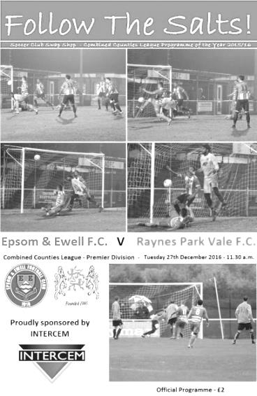
Late equaliser costs more points

The second meeting of the season between these two clubs came on Tuesday morning and ended in the same way as the first with the away team securing an equaliser with almost the last kick of the match. For the Salts it was particularly frustrating as we had only been in front for eight minutes and were looking to hold on for an important win.

In all honesty though, this result was not a great surprise as recent home matches have followed a similar pattern with AFC Hayes taking a point with two late goals and Chertsey only just failing to copy them. We may remain unbeaten at home in the league since August but it is these matches that are hurting us most as we appear to have done the hard work, only to fall apart just when it looks as though we are home and dry.

Player selections haven't helped our cause recently and we had yet another short bench for this match, despite only one player, Matt Tanton being suspended. At Grand Drive in October we had just one fit player available but we were arguably worse off this time with our only regular fit outfield player Daryl Cooper-Smith being called into the starting line-up at short notice due to a pre-match injury to Jason Nwachukwu.

Needless to say we finished the match with the same eleven that started it. That said, the opposition had to field defender Anthony Moulds in goal so they weren't exactly at full strength either; his last visit here resulted in a comedy own goal that set us on the way to a 3-1 win but he made some good saves and will have happier memories of this match than his previous one.

We started brightly and pushed the visitors back as early as the second minute when an Agi Panayiotou sent a corner in that led to the ball bouncing all over the place before being fallen on by the grateful Moulds and he was alert to deal with a snapshot from Rob Hendry from the edge of the area. Next to try his luck was Jordan Gallagher who found himself in acres of space in the 12th minute , letting fly from the around twenty yards but he couldn't keep the ball down.

We had a scare in the 16th minute when Craig Hastings had to divert a dangerous right wing cross just over his own bar and five minutes later the visitors had a try from twenty-five yards but Michael Eacott was ready for it and saved comfortably. Their opportunities came rarely though and we were back on the attack in the 35th minute when a James Taylor cross from out on the right was met at the far post by Gallagher but instead of heading across goal to waiting strikers he volleyed it back, but too close to goal where Moulds was able to claim it.

We came closest to scoring in the 40th minute when Taylor found Hendry who cleverly beat two men before shaping to shoot, only to put Matt Farrell through on goal. However, Moulds was out to block his shot really well and received a bonus when the ball then bounced back off our man and out for a goal kick! More frustration ensued in injury time when Cooper-Smith put in a great low ball on the right which was knocked into the net from close range by Hendry but despite him appearing to run past the nearby defender to get to the ball he was adjudged offside. There was also time for Hendry to jump well to reach a Cooper-Smith cross but he headed the ball just beyond the far post.

We had finished the half strongly and nearly took the lead through a defensive error which left Hendry clean through just eight yards out. It really needed a bit more composure as the keeper was already going to his left but Hendry went for power instead and Moulds saved his shot.

This was concerning as we struggled to create very little for quite a while. The match was played out in midfield with not a lot of space for either team but we needed to find another gear if we were to break through. Hendry crossed for Cooper-Smith but the ball had very little on it and our leading striker was only able to hit the target but with little power and Moulds was there again.

Finally, in the 84th minute we broke through and a ball over the top found Hendry in space and in a similar position to that which he had found himself in earlier. Once again he went for power, but this time his shot flew into the bottom corner to surely clinch the points.

Unfortunately things then changed from that point. The visitors pressed and we suddenly looked really nervy, conceding free kicks and possession frequently. This time it would cost us as Adam Roberts got through on the right and appeared to squeeze his shot past Eacott from a narrow angle in the second minute of injury time. It was the second time in recent years that Vale had pinched a draw in the dying seconds at High Road and we clearly need to do something about this going forward.

Epsom and Ewell: Michael Eacott, James Taylor, Reisse Griffin, Craig Hastings,
Dan Dean (c), Savvas 'Agi' Panayiotou, Jordan Gallagher, Matt Farrell,
Rob Hendry, Daryl Cooper-Smith, Adam Heagney

Subs: none

From behind the goal
Sutton Common Rovers 1-1 Epsom & Ewell
Combined Counties League - Premier Division - Monday 2nd January 2017

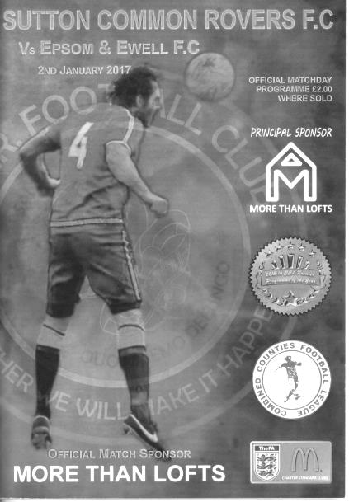
Ten man Salts secure point with late rally

We kicked off the New Year with a trip to Sutton United, the temporary home of Sutton Common Rovers for a League match, aiming for our fifth straight "double" over them. However, in a match with few chances we were unable to secure the win we needed to keep the sequence going and needed a late equaliser to take anything at all out of the contest.

We made just the one change from our draw against Raynes Park Vale with Matt Tanton coming in after completing his one match suspension, taking the place of Craig Hastings who was serving his own one match suspension! There was a little bit of juggling of positions but the players were back in their preferred positions for this match as a result.

The first opportunity of the match fell to us in the eighth minute when we were awarded a free kick. As it was floated in, both Dan Dean and Daryl Cooper-Smith found themselves in a lot of space. Unfortunately they got in each other's way a little and when our Captain made contact with the ball, it went across goal where it fell just out of reach of the incoming James Taylor.

In response the home side had a couple of shots from distance, but regrettably they were successful with one of these in the 21st minute when Michael Campbell tried his luck from fully thirty yards. Michael Eacott was stretching a little but instead of tipping the ball over the bar, he made a fuller contact which took all the pace out of the shot and the ball dropped almost apologetically over the line.

Not for the first time in recent weeks, the goal knocked the stuffing out of us and we struggled to create anything for a while. We did earn a couple of identical free kicks for fouls on the edge of the area against Matt Tanton and then Rob Hendry but Cooper-Smith failed to really test veteran keeper Craig Bradshaw with either and he was able to gather both attempts fairly easily, which was just as well for

him as we had players running in on both occasions that would have finished off any loose ball.

Although we had created very little, the same could be said for the opposition and this pattern continued into the second half. Dean picked up a yellow card for a fairly agricultural body check while we nearly equalised after the ball had slipped under a defender's foot and Cooper-Smith was through, but as he attempted to cut back onto his right foot a challenge came in and sent the ball out for a corner less than a foot wide of Bradshaw's right hand post. From the set piece a good ball in that was half cleared but Dean's low drive from the edge of the area was just wide of the post.

Almost immediately Sutton Common Rovers were on the attack on the left wing and the ball was crossed in to Campbell who found his powerful shot repelled by the advancing Eacott but the loose ball fell to former Salt Matt Robinson and his shot beat Eacott but was blocked on the line by Dean and we cleared the danger.

The game was starting to open up a little and we made a couple of substitutions with Cooper-Smith and Reisse Griffin being replaced by Jason Nwachukwu and Matt Ferdinando. We then earned a corner that was taken by Rob Hendry but was headed just wide by Dean. However, his match was about to end prematurely as he picked up a second yellow for a foul on Campbell in the 77th minute.

Things were looking bleak, but if anything we improved from this point and in the 81st minute we were level after a good ball in from the right was met by Hendry who found Jordan Gallagher just eight yards out who took a touch before finishing clinically into the bottom corner. The home side attacked on the left but Eacott was out quickly to make the save and as the game closed we looked the stronger of the teams but we were unable to pinch a winner despite a trademark Ferdinando mazy run but he dragged his shot wide from the edge of the area and we finished all square.

In summary it was a quiet game where neither team did enough to say they deserved to win, but the harsh reality is that a point didn't really help us a lot. We have now drawn three of our last four matches and are beginning to slip down the table. Saturday's game at home to Spelthorne Sports now assumes greater importance as a result.

Epsom and Ewell: Michael Eacott, Adam Heagney, Matt Tanton,
James Taylor, Dan Dean (c), Savvas 'Agi' Panayiotou, Jordan Gallagher,
Matt Farrell, Rob Hendry, Daryl Cooper-Smith, Reisse Griffin

Subs: Matt Ferdinando for Griffin (64),
Jason Nwachukwu for Cooper-Smith (64)

Spelthorne Sports F.C. – History

Spelthorne Sports Club was founded in 1922 having purchased around 11 acres of land and has been providing sports for the local community ever since. We currently have 2 full sized football pitches and field 3 adult football teams and 2 Sunday teams along with a Youth Section covering Little Kickers through to the Mid-week Flood Lit Under 18’s, a total of 21 youth teams competing every Sunday in the Surrey Youth and Surrey Primary Leagues. The Youth Section was awarded the FA Charter Standard in March 2010 and the Annual Youth Tournament draws in many local teams since its inauguration in 2010.

In season 1998-99, Richard Ford and Micky Fisher took control of their 1st full season and saw them rise up the table. Both players were long serving Spelly players and had now moved into the management side. The team were led by Paul Fernadez with Paul Wilson in goal and Ian & Nick Croxford playing their 1st seasons with Spelly. We finished the season in 3rd spot and reached the final of the Russell Grant cup, where Sports did their usual thing of blowing it and lost to Northolt Saints 2-0 in the final at Uxbridge after they had beaten and drawn with them earlier in the season.

2001 was the first season of the new management team of Paul Martyn Jones (Trigger) and Ian Croxford. The team had the two scoring machines of James (OGGY) Hogg and Nick Croxford playing up front and with eventual player of the year Wes Coles in goal this was the most successful season for many a year. The team went from October through to April without losing a league game taking the league title in front of Willesden Constantine by 5 points, they were on the road to a league and cup double but were beat in the semi finals by Willesden with future professional footballer Enoch Showammi smashing home a 25 yard free kick.

In 2007, after many great years playing in the Middlesex league it was decided that a move to the Surrey League was required. The main driving force for this was that the league had expanded in such that game were all across London and for an amateur side an away trip to Bethnal Green was an all day event. The move to the Surrey Western was a change that was needed with pleasant drives through the country playing village teams rather than long hauls across London.

With the management now in the hands of Steve Flatman, a long time player and member of the club, the team saw a steady growth and this has to be credited to Steve. The first season saw Sports finish 7th with Horsley running away with the league. The next season saw some old faces come back into the team to support the young bucks with Oggy, Mike Jenkins and Ian Croxford coming back to support the team. The team finished second behind Ripley with Rob Smith finishing top league scorer with 21 and Lee Staples not far behind on 19. The season had its climax when Sports played their first final in many a year against Abbey Rangers at Cobham FC and with the team leading 1-0 at half time through a Jake Flatman goal they somehow grabbed defeat from the jaws of victory losing 2-1 with a spectacular 20 yard own goal from Aaron Stewart.

In 2009, Spelthorne Sports again moved leagues for the second time in three seasons as we progressed up through the FA pyramid system, this time to the Surrey Elite league. The season started well but it was discovered that a (nameless) player had played with a ban from his now disbanded Sunday team. This resulted with Spelly being deducted all points that had been awarded while he was playing that season, 9 in total. Spelly finished the season 5th but if we had not lost the points we could possibly have finished third or even higher as the disappointment of losing these points was a bitter pill to swallow.

In the 2010-11 season Spelthorne Sports Football Club 1st Eleven Completed a league and cup double victory by winning the Surrey Elite Intermediate League and the Surrey intermediate Challenge cup. Their league success means they won promotion to the combined counties league which covers levels 9 and 10 of the English Football League System.

In 2013–14, the Spelly won the Middlesex FA Intermediate Cup, beating Middlesex County Premier side Cricklewood Wanderers 3–0 in the Final. On 16 April 2014, Spelthorne Sports were crowned Combined Counties Division One Champions with a 2–1 win away to Epsom Athletic. They lifted the trophy 3 days later following an emphatic 7–0 win at home to local rivals Staines Lammas. The Spelly also won the RPM Records Division One Challenge Cup against Staines Lammas at Windsor FC on 5 May 2014. A single second half Lee Staples goal was enough to make sure The Spelly lifted the trophy, winning the league and cup treble in the process.

The team went on a phenomenal 46 game unbeaten run in all competitions that season, beating teams in cup competitions from higher divisions such as Frimley Green, Staines Town (on pens), Walton Casuals, Wembley, and Epsom & Ewell (on pens). That unbeaten run finally came to an end on 7 May 2014 when they played Combined Counties Premier Division side Hanworth Villa in the Southern Combination Cup Final, losing 1–0. The game was played at home and marked the club's first ever game under the newly installed floodlights. The lads then suffered their second defeat of the season to the same opposition when the sides met again 3 days later in the Cherry Red Records Premier Challenge Cup Final, again losing 1–0.

The 2013–14 season was extremely successful for Spelthorne Sports. Winning two cup finals, and finishing runners-up in another two cup finals. However the biggest achievement by far was winning the league without losing a single game in the process. Winning 22, drawing 8, losing 0, scoring 92, and conceding 23.

Season 2014-2015 saw us in action in the Combined Counties Premier Division where we finished in a very respectful 6th position. We also experienced our first entry into the FA Vase. The promotion led to vast ground improvements yet again and this work continues to be done.

This season sees a change of management back under the control of Steve Flatman with support from Paul Burgess and Mark Harper. We are looking forward to seeing the continued development of football at ‘The Spelly’.

Club Records - 7th January
Date | Day | Competition |  | Opponents |  | Scorers
07/01/28 | Sat | London League | A | Tooting Town | 2-0 | F.Watts (2, 1pen)
07/01/33 | Sat | London League | H | Carshalton Athletic | 10-1 | L.Marlow (5), R.Marlow (2), A.Rance, L.Graves,  G.Mackesy (pen)
07/01/39 | Sat | London League | A | Eton Manor | 2-4 | J.Jones (pen), A.Curtis
07/01/50 | Sat | Corinthian League | H | Eastbourne | 2-2 | W.Warwick, C.Rooke
07/01/56 | Sat | Surrey Senior Cup QF | A | Tooting & Mitcham United | 0-2
07/01/61 | Sat | Corinthian League | H | Dorking | 2-1 | S.Dunwoody (2)
07/01/67 | Sat | Athenian League 2 | H | Herne Bay | 1-1 | T.Farmiloe
07/01/78 | Sat | Isthmian League 2 | A | Eastbourne United | 4-1 | T.Tuite (2), G.Butler, S.Delaney
07/01/84 | Sat | Isthmian League 1 | A | Boreham Wood | 1-3 | S.Hill
07/01/86 | Tue | Isthmian League  Premier Division | A | Harrow Borough | 0-3
07/01/89 | Sat | Surrey Senior Cup 1 | H | Malden Vale | 2-0 | N.Robson, o.g.
07/01/92 | Tue | Associate Members Trophy 2 | H | Royston Town | 4-1 | A.Webster (3), A.Skeet
07/01/06 | Sat | Isthmian League 2 | A | Brook House | 0-2
07/01/12 | Sat | Combined Counties  League Cup 2 | A | Worcester Park | 1-4 | J.Cottee
Historical Decades
90 years ago – Epsom Town F.C.
08/01/27 | Sat | Surrey Senior League | A | Weybridge | 8-0 | R.Marlow (4), T.Birch (2),  J.Parr (2)
80 years ago – Epsom F.C.
09/01/37 | Sat | London League | A | Tilbury | 2-0 | G.Collins, H.Pullen
70 years ago – Epsom F.C.
04/01/47 | Sat | London League | H | Dartford Reserves | 3-0 | G.Brogdale (2), R.Chenery
60 years ago – Epsom F.C.
05/01/57 | Sat | Corinthian Memorial Shield 2 | H | Slough Town | 1-1 | J.Bangs
50 years ago – Epsom & Ewell F.C.
07/01/67 | Sat | Athenian League 2 | H | Herne Bay | 1-1 | T.Farmiloe
40 years ago – Epsom & Ewell F.C.
08/01/77 | Sat | Athenian League 1 | A | Lewes | 1-5 | M.Peters
30 years ago – Epsom & Ewell F.C.
10/01/87 | Sat | Isthmian League 1 | H | Boreham Wood | 2-0 | R.Kidd, T.Tuite
20 years ago – Epsom & Ewell F.C.
14/01/97 | Tue | Associate Members Trophy 2 | A | Met Police | 0-1
10 years ago – Epsom & Ewell F.C.
20/01/07 | Sat | Combined Counties  Premier Division | H | Bedfont | 1-0 | A.Myers

History Corner – 7th January
90 years ago tomorrow we visited Weybridge for a Surrey Senior League match. We were reigning Champions and would repeat this season, adding the Charity Cup for a memorable double, and this was an indication of how far we had come as we smashed them 8-0, with Reg Marlow scoring four times, while Terry Birch and Jack Parr shared the other four. Weybridge were a famous old side that had defeated the previous tenants of West Street, Ewell F.C. 2-0 in the 1899 Surrey Senior Cup Final, and were a top half team this season too, but just two months after this result we would be battering them 10-0 at West Street to gain a very delayed revenge on Ewell’s behalf!

83 years ago today we hosted Carshalton Athletic at West Street and obliterated them by ten goals to one in a London League match. We secured many large wins against our local rivals back in the pre-war days and even though we haven’t beaten them since 1955, they are still the team we have scored most goals in our history against with 194!

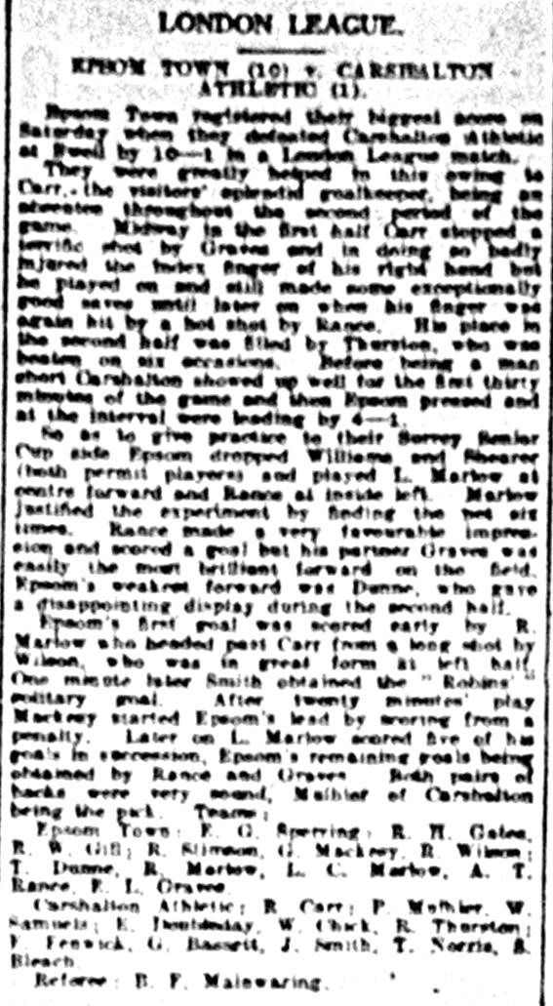
This day, although Reg Marlow scored twice it was his namesake, the unrelated Leslie Marlow who would take the plaudits with five goals. A.T. Rance, Leslie Graves and George Mackesy from the spot completed the rout. Incidentally, we would also win 10-1 the following season against Grays Athletic, with Leslie Marlow equalling the club record with six goals, a tally that has been matched a couple of times since but never bettered.

25 years ago today Andy Webster scored a hat trick as we defeated Royston Town 4-1 in an Associate Members Trophy tie. Webster was a great striker full of promise but suffered an injury prone existence with us and spent much of the following season out of football entirely before leaving us, quite possibly retiring from the game at that point.

Centre page for results

Centre page for results


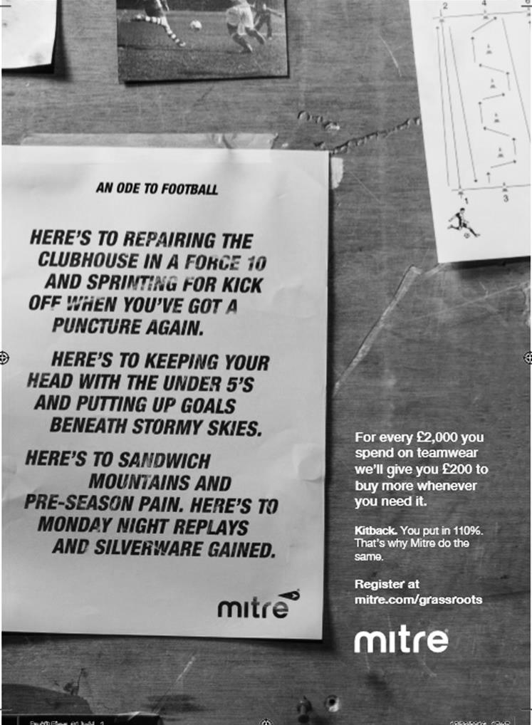

Surrey Senior Cup
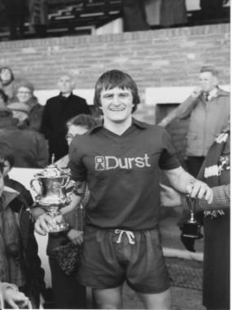
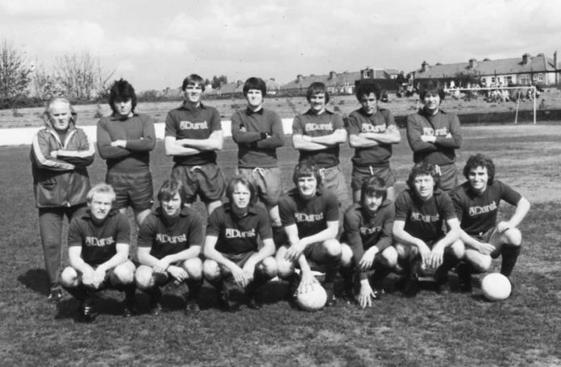
Second Round
Met Police | 0-0 | Kingstonian
Match played at Met Police F.C. – Kingstonian won 7-6 on penalties
Ashford Town (Mx) | 0-1 | Knaphill
Woking | 4-0 | Walton Casuals
Whyteleafe | 5-1 | Colliers Wood United
Guildford City | 3-3 | Horley Town
Guildford City won 3-2 on penalties
Egham Town | 3-0 | Corinthian Casuals
Godalming Town | 0-1 | Merstham
Molesey | 0-1 | Leatherhead
Raynes Park Vale | 1-1 | Sutton United
Raynes Park Vale won 4-3 on penalties
Sutton Common Rovers | 5-1 | Camberley Town
Dorking Wanderers | 2-1 | South Park
Badshot Lea | 1-0 | Farnham Town
Walton & Hersham | 3-0 | Croydon
Carshalton Athletic | 0-2 | Tooting & Mitcham United
Chertsey Town | 2-1 | Abbey Rangers
Epsom & Ewell | 3-0 | Chipstead
Third Round
Whyteleafe | 24/1 | Egham Town
Badshot Lea | 10/1 | Raynes Park Vale
Epsom & Ewell | 10/1 | Guildford City
Dorking Wanderers | 24/1 | Sutton Common Rovers
Kingstonian | 10/1 | Chertsey Town
Woking | 10/1 | Leatherhead
Merstham | 10/1 | Walton & Hersham
Tooting & Mitcham United | 24/1 | Knaphill

EL Records Premier Challenge Cup
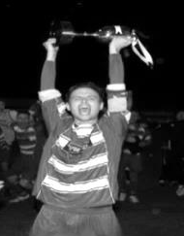
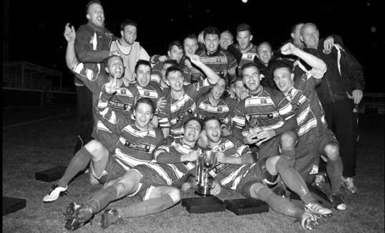
Second Round
Hanworth Villa | 2-4+ | Epsom and Ewell
AFC Hayes | 3-4 | Balham
Epsom Athletic | 1-5 | Windsor
Sutton Common Rovers | 2-1 | Bedfont Sports
Raynes Park Vale | 2-0 | Colliers Wood United
Frimley Green | 1-2 | Banstead Athletic
Westfield | 8-4+ | Redhill
Staines Lammas | 0-1 | Farnham Town
Worcester Park | 8-1 | Cove
Badshot Lea | 0-5 | Guildford City
Chertsey Town | 1-2 | Camberley Town
Cobham | 1-3 | Chessington & Hook United
Hartley Wintney | 4-0 | AC London
Horley Town | 2-2+ 5-4p | Sheerwater
Walton & Hersham | 5-1 | Eversley & California
Ash United | 2-0 | Farleigh Rovers
Third Round
Banstead Athletic | 4-4+ 3-4p | Westfield
Sutton Common Rovers | 19/12 | Walton & Hersham
Farnham Town | 0-4 | Camberley Town
Ash United | 0-2 | Windsor
Raynes Park Vale | 2-1 | Hartley Wintney
Guildford City | 2-1 | Balham
Horley Town | 2-0 | Chessington & Hook United
Worcester Park | 3-6 | Epsom & Ewell
Quarter Finals
Windsor | 24/1 | Horley Town
Guildford City | 25/1 | Raynes Park Vale
Westfield | 17/1 | Camberley Town
Walton & Hersham | 31/1 | Epsom & Ewell

Every Opponent A-Z

Over the years we have played many, many different opponents. Exactly how many is a difficult question, as it all depends on your definition. Are Camberley & Yorktown different to Camberley Town, or are Epsom Town different to Epsom F.C. or Epsom & Ewell F.C.?

In my analysis I have classed both of the above examples as the same team, and will work through them all from A to Z. Some we have played many times, whilst others we have met just once or twice. Enjoy!

Tunbridge Wells: Played 4 - W2 D1 L1 - F7 A7 - PPG - 1.75 - Good

The Wells are a famous club who have played right at the top of the Amateur game. Originally formed back in 1886 and with a name that fluctuated between Tunbridge Wells Rangers and simply Tunbridge Wells they competed in the Southern League before World War One and for two seasons 1911/12 and 1912/13 they played in the Isthmian League, based at a ground called Ferndale. They folded in 1967 but reformed immediately so I believe they can claim a continuance, making them 131 years old this year!

We didn’t meet them until 7th September 1996, by which time they were a regular Kent League team, defeating them 3-1 at Merland Rise in the F.A.Vase. In fact all four of our meetings have come in that competition, with the next one on 25th September 1999 also going in favour of our boys by a score of 2-1 on a very wet day on our first ever visit to their ground of many years, the Culverden Stadium.
The impressive full length stand at the otherwise unimpressive Culverden Stadium

The final two meetings came in the 2007/08 season, where we were held 2-2 after extra time at Merland Rise, before returning to Kent for the replay exactly eight years to the day after our previous visit, although this time we were buried 3-0.
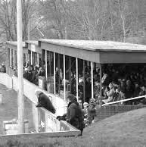
They remain in the Kent League, where they mark their 50th consecutive season this term, even though the name of the competition has changed to the Southern Counties East League, but had one major shot at fame, losing to Spennymoor Town in the F.A.Vase Final of 2013. However, the run cost them league points in a horribly wet season and the chance

of taking the players through to Step Four were gone. Ironically we nearly met this year, but they were dumped out of the Vase 3-0 by Abbey Rangers, who of course then went on to knock us out in the next round.

Twickenham: Played 1 - W1 D0 L0 - F3 A2 - PPG - 3.00 - Perfect

Twickenham first appeared as founder members of the Corinthian League in 1945/46 and played twice against the war time Epsom Town club that had also joined up that year. They didn’t appear to have a home ground though and both matches were played at Epsom’s grounds, at Lavender Avenue in September 1945 and at the Old Halleyburians ground in Ruxley Lane in March 1946 with the Epsom club winning 2-1 and 3-1 respectively.

The Epsom Town club folded in 1946 and Twickenham may well have done likewise as they also left the Corinthian League. A few years later they joined the newly formed Metropolitan League, but had left it in 1953 and by the time of their one meeting against us on 27th October 1956 they were a Parthenon League club.

By then we were a half decent Corinthian League club in the process of having a great season, yet we trailed at the half before turning the match around to win 3-2 with two goals from Johnny Bangs and the other from Brian Jenkins.

They became Champions of the Parthenon League in 1958/59 and were still there in 1966 but it is not clear what happened to them after this time, which is when the Parthenon League was effectively replaced by the Middlesex League.

Ulysses: Played 6 - W2 D2 L2 - F7 A7 - PPG - 1.33 - Average

Ulysses were an Old Boys team that had connections to London University and played at Motspur Park, which is now I believe where Fulham do much of their training.

We first met them for a friendly challenge match on 25th April 1959, drawing 1-1 at West Street with Bert Lambert scoring for us (no relation!).

By the time of our next meeting, an Amateur Cup tie on 24th September 1966 they were probably in the lower reaches of the London League, as they had been there in the early sixties and were founder members of the Metropolitan – London League in 1971. Despite this, they knocked us out 3-1 and it could have been worse but Terry Self saved a penalty.

We met in the same competition the following season where again they proved a tough nut to crack; Epsom requiring extra time in a replay at Motspur Park to progress 3-1 after a 1-1 draw the previous Saturday, despite having players of the calibre of a young Chris Kelly in the side, who was one of the scorers that day.

We finally had a first time success on 8th November 1969 when we defeated them 1-0 in a Surrey Senior Cup tie with the scorer being Shaun Smyth, the owner of our programme printers!

However, and against the odds, this tiny side who would be destined to finish 14th out of 14 in Division 1 of the London – Metropolitan League, somehow won 1-0 at West Street against an admittedly fledgling Pat O’Connell managed Epsom team on 29th September 1973. It was to be our final Amateur Cup tie and we have arguably never been beaten by a team at such a low level in our entire history, before or since.

They remained at a similar level before becoming members of the London Spartan League after the Leagues merged in 1987, although the standard proved too much and they departed in 1991. It appears that the club may still have been around until recently and may still exist in Amateur Leagues, but playing out of Norbury in more recent years, quite possibly at the old Barclays Bank ground that used to exist there, but this would be an educated guess!

Combined Counties League Premier Division Opponents
All-time Records
incl Monday 2nd  January | P | W | D | L | F | A | PPG | GD | Best  Win | Worst  Loss
Bedfont & Feltham | 1 | 1 | 0 | 0 | 9 | 2 | 3.00 | +7 | 9-2 | X
Spelthorne Sports* | 5 | 4 | 1 | 0 | 15 | 6 | 2.60 | +9 | 6-2 | X
Sutton Common Rovers | 12 | 9 | 2 | 1 | 30 | 14 | 2.42 | +16 | 4-0 | 1-4
Horley Town | 29 | 20 | 5 | 4 | 65 | 30 | 2.24 | +35 | 6-0 | 1-3
Colliers Wood United | 22 | 14 | 2 | 6 | 45 | 33 | 2.00 | +12 | 4-0 | 0-5
Bedfont Sports | 10 | 6 | 2 | 2 | 18 | 11 | 2.00 | +7 | 5-1 | 0-4
Abbey Rangers | 3 | 2 | 0 | 1 | 10 | 4 | 2.00 | +6 | 7-1 | 2-3
Westfield | 19 | 11 | 3 | 5 | 40 | 31 | 1.89 | +9 | 6-1 | 0-4
Farnham Town | 14 | 8 | 2 | 4 | 25 | 23 | 1.86 | +2 | 3-1 | 1-4
Knaphill | 7 | 4 | 1 | 2 | 15 | 8 | 1.86 | +7 | 4-0 | 1-2
Guildford City | 17 | 10 | 1 | 6 | 34 | 22 | 1.82 | +12 | 5-1 | 1-5
Hanworth Villa | 16 | 8 | 4 | 4 | 38 | 26 | 1.75 | +12 | 5-0 | 1-4
Badshot Lea | 18 | 8 | 3 | 7 | 35 | 34 | 1.67 | +1 | 4-1 | 0-4
Walton & Hersham | 50 | 24 | 10 | 16 | 101 | 97 | 1.64 | +4 | 6-0 | 0-8
Raynes Park Vale | 28 | 13 | 7 | 8 | 59 | 38 | 1.64 | +21 | 6-1 | 0-2
Camberley Town* | 89 | 38 | 22 | 28 | 158 | 123 | 1.52 | +35 | 9-1 | 0-4
Hartley Wintney | 11 | 4 | 3 | 4 | 26 | 20 | 1.36 | +6 | 5-0 | 2-4
Windsor | 49 | 19 | 12 | 18 | 90 | 90 | 1.41 | 0 | 4-0 | 0-6
Chertsey Town | 48 | 18 | 5 | 25 | 72 | 87 | 1.23 | -15 | 3-0 | 0-7
AFC Hayes | 9 | 2 | 3 | 4 | 18 | 17 | 1.00 | +1 | 7-0 | 0-3
North Greenford United | 11 | 3 | 2 | 6 | 15 | 20 | 1.00 | -5 | 3-0 | 1-4
CB Hounslow United | 2 | 0 | 0 | 2 | 2 | 7 | 0.00 | -5 | X | 1-5
* includes one abandoned match v Camberley and one loss on penalties v Spelthorne

My Club Betting

We can now announce that Epsom & Ewell F.C.
now have our own betting site!

If you like to have a bet, this is most definitely for you.

In conjunction with MyClubBetting.com you can now access all the regular markets that you might do regularly with just a click on our website.

But why would you do this? Many of you already might have apps that you currently use.

The main reason is that you would benefit the club by doing so, but at the same time would not lose out yourselves. Their odds are at least comparable and in many cases better than the other bookmakers out there and by registering with us, the club would make 20% of any cumulative losses and with enough usage, we would qualify for other fairly substantial club benefits.

If you win the bet that you place, that is fantastic news, but whichever company you use currently would keep 100% of any losses. This way our club can receive a nice lump sum in the event that you are unlucky.

For example. If we have 20 people signed up and they lost £25 over the month each, our club would receive £100 back out of the £500 lost.

So just visit: https://eefc.myclubbetting.co.uk/ and join the club!

Player Sponsorship
Here is the current list for the 2016/17 season showing all of our players and Management that are available for sponsorship.

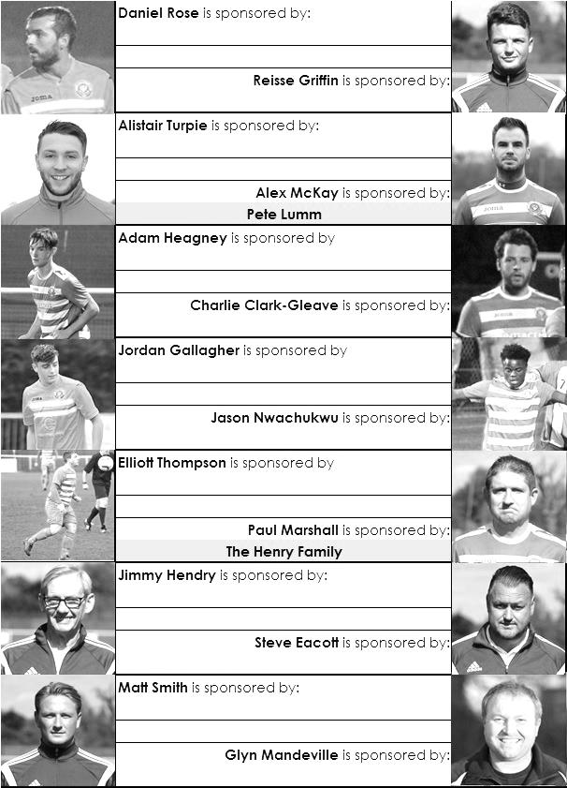

Sponsorship costs just £40 and it is easy to do. Just select a player who has not been previously sponsored and let a Committee Member know that you would like to sponsor them. Beware though. Until we have received the money it is possible for someone to jump in front of you, so don’t delay, sponsor today!
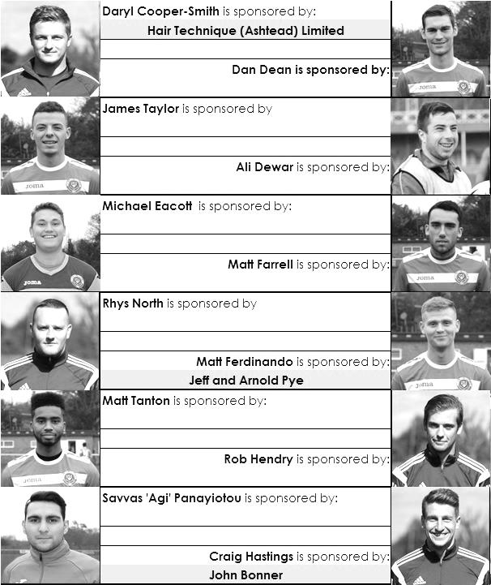

Match and Ball Sponsorships – 2016/17
Opponent | Date | Match Sponsor | Ball Sponsor
Gravesham Borough | 07/08/16 | Club President - Stella Lamont
Gravesham Borough | 07/08/16 | Relocation Committee Member - Mike Lovett
CB Hounslow United | 16/08/16 | EEFC Management Committee
Abbey Rangers | 23/08/16 | Steve & Geoff Dyke
Horley Town (11.30am) | 29/08/16 | In Memory of Chris Henry
Abbey Rangers (LC) | 06/09/16 | Paul Merritt
Camberley Town | 10/09/16 | Building Shop Ltd
Knaphill | 24/09/16 | EEFC Holding Company Director – Pete Lumm
Bridon Ropes (FAV) | 22/10/16 | George and Joseph Saunders
Sutton Common Rovers | 08/11/15 | Alex McKay Senior
Abbey Rangers (FAV) | 13/11/16 | EEFC Holding Company Director – Dave Ellins
Windsor | 15/11/16 | In Memory of Wally Dyke
Bedfont Sports | 19/11/16 | John Bonner
AFC Hayes | 26/11/16 | Jack Jarman
Chipstead (SSC / DWT) | 06/12/16 | Trevor Stotten
Hanworth Villa | 13/12/16 | Roger and Carol Farrell
Chertsey Town | 17/12/16
Raynes Park Vale (11.30am) | 27/12/16 | In memory of Dave and Liz Marshall
Spelthorne Sports | 07/01/17 | Building Shop Ltd
Guildford City (SSC) | 10/01/17 | Super Six Winner – Rita Christian
Guildford City | 17/01/17
Bedfont & Feltham | 21/01/17 | Programme Editor - Richard Lambert
Badshot Lea | 04/02/17
Westfield | 18/02/17
Walton & Hersham | 04/03/17
Hartley Wintney | 18/03/17
Farnham Town | 25/03/17
Colliers Wood United (1pm) | 14/04/17 | Good Friday match – make a note!
North Greenford United | 22/04/17 | Club President - Stella Lamont
For League, League Cup and Surrey Senior Cup Matches:
Match sponsorship - £40.00 Match ball sponsorship - £25.00. Combined £55.00.
For F.A. Cup and F.A. Vase matches:
Match sponsorship - £50.00 Match ball sponsorship - £30.00. Combined £65.00.

Sponsorship includes: (x2 for match, x3 for match and ball)

Admission, programmes, hospitality and advertising and mascot for the day (if required).
If you are interested, just speak to a Committee Member, or drop me an email at: richard.c.lambert@gmail.com


We also thank our Kit Sponsors INTERCEM

Salts Super Six Predictor
The Salts Super Six Predictor is live again for today’s match and the tickets are on sale at today’s game to the left of the gate.

The jackpot was won recently, but is already increasing and is now up to £165.

The competition is easy to play! To win, you simply need to predict the results of six matches correctly from the three options, fill in the form and make sure it is back with our seller before the deadline on the ticket. The latest fixtures are shown below.

If you are a club regular, you just need to place your name on the sheet, although if you aren’t, then we’ll need a contact number from you too. We will announce any winners on the website within three working days, so don’t worry, we won’t miss you!

Please note that if there is more than one winner, the prize pot would be shared between the winners. All you need to do now is have a go, as many times as you like!

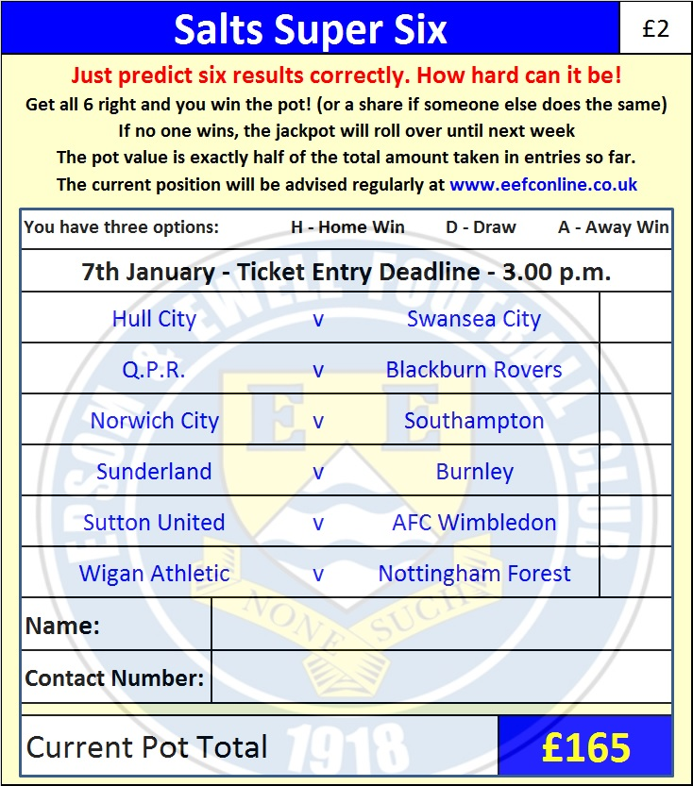
Good luck!

Combined Counties League – Premier Division
Saturday, 7th January 2017 - Kick-off 3.00 p.m.

Epsom and Ewell  (Royal Blue & White hoops) | V |  | Spelthorne Sports  (All White)
Squad | NUMBERS |  | Squad
Michael Eacott |  |  | Jacob Fuller
Adam Heagney |  |  | Jack Horsfall
Matt Tanton |  |  | Lewis Taylor
James Taylor |  |  | Joe Dyett
© Dan Dean |  |  | Sam Rees
Savvas ‘Agi’ Panayiotou |  |  | Josh Remedios
Jordan Gallagher |  |  | Jake Flatman
Matt Farrell |  |  | Callum McKay
Rob Hendry |  |  | Jack Ball
Daryl Cooper-Smith |  |  | Jamie Read
Reisse Griffin |  |  | Lewis Flatman
Jason Nwachukwu |  |  | Tom Peel
Matt Ferdinando |  |  | Callum Beauchamp
Craig Hastings |  |  | Quaseem Soronwa
Alex McKay |  |  | Lee Staples
Daniel Rose
Alistair Turpie
Charlie Clark-Gleave
Matt Smith
Glyn Mandeville | MANAGER |  | Steve Flatman
Matt Smith | ASSISTANT |  | Mark Harper
Steve Eacott / Alex McKay /  Jimmy Hendry | COACHES / PHYSIO |  | Paul Burgess
REFEREE: H.Read
ASSISTANTS: R.van Niekerk, M.Flannery-Pratt
Today’s Match and Match Ball are kindly sponsored
By The Building Shop Ltd

OUR NEXT VISITORS TO HIGH ROAD
Guildford City
Surrey Senior Cup – Third Round
Tuesday 10th January 2017 – 7.45 p.m.

